Analyzing Short Term Rental Investment in Broward County, Florida

Technical Write-up

Abhishek Shrestha, Alexis Espino, & Rajarajeshwari Muthusamy Periyasamy

# Introduction

The focus of this analysis is to assist Amy and Addy, two sisters from Hazelhurst, Georgia, who are looking to purchase an investment property with quick access to a beach that allows swimming or snorkeling. They require this property to be within 8 hours driving distance from their main home, and also be within 20 minutes of a business district. The sisters plan on using the property 4 weeks out of the year and intend for it to be listed as a short term rental for the rest. This will be done with the goal of covering the most of the cost of ownership through the rental income.

Additional details to the scenario are that the sisters have a combined income of $ 120,000.00 and that they are able to give an upfront downpayment of $ 60,000.00. They have a budget of $ 400,000 for buying a property.

# Background

More often than not, people make decisions regarding real estate investments through their own research and/or consulting with a realtor or a real estate broker. Reliance on one’s own capabilities for research and being able to analyze market trends can lead to success. Talking to professionals who have a hand on the pulse of the industry can lead to unique insights, better chances of making a good investment, and ease of making a decision and purchase. However, these methods of going about looking at investment properties has a limitation with regards to what is one’s own abilities and available time. It is not unreasonable to make the assumption that real estate professionals have expertise in certain locations and not a wider range of it.

Through the use of data and the analysis of it, personal limitations and possible biases can be eliminated from the process of choosing a location for investment. Even more so, from data, predictions with regards to possible income and occupancy can be made for several locations of consideration in a shorter amount of time.

Broward County was selected due to its location on the eastern coast of Florida with closer proximity to the beaches that are suitable for swimming and snorkeling and its inclusion in the Miami metropolitan area. Just as important, Broward County is within 8 hours driving distance from the sister’s home in Georgia. Within the county are 31 cities/neighborhoods. These are:

| Parkland | Lauderdale-by-the-Sea | Davie |
| --- | --- | --- |
| Coconut Creek | Sea Ranch Lakes | Dania Beach |
| Deerfield Beach | Oakland Park | Hollywood |
| Coral Springs | Wilton Manors | Southwest Ranches |
| Margate | Lazy Lake | Cooper City |
| Pompano Beach | Fort Lauderdale | Pembroke Pines |
| Lighthouse Point | Lauderdale Lakes | Miramar |
| Hillsboro Beach | Lauderhill | West Park |
| Tamarac | Sunrise | Pembroke Park |
| North Lauderdale | Plantation | Hallandale Beach |
|  | Weston |  |

Not all 31 can be considered as possible locations for the sisters. One of the requirements that they have is that the property be within walking/cycling distance from a beach where people can snorkel and swim. With that in mind, 10 cities that are along and/or near the coast of Florida are left for consideration. These are:

| Deerfield Beach | Sea Ranch Lakes |
| --- | --- |
| Pompano Beach | Fort Lauderdale |
| Lighthouse Point | Dania Beach |
| Hillsboro Beach | Hollywood |
| Lauderdale-by-the-Sea | Hallandale Beach |

Another factor considered is proximity to a business district that has restaurants and other establishments for entertainment or leisure. The location of the investment property needs to be within 20 minutes driving distance from the business district. From the remaining 10 cities that are in consideration, Fort Lauderdale is included. It is the county seat, the largest city, and the central business district of Broward County. To further funnel down the selection of cities, distance from Fort Lauderdale is determined.

| Pompano Beach | Dania Beach |
| --- | --- |
| Lauderdale-by-the-Sea | Hollywood |
| Sea Ranch Lakes | Hallandale Beach |
| Fort Lauderdale |  |

Seen in the table above are the 7 cities that are left for consideration for the potential investment property that fulfills the requirements of the sisters.

# Technical Details

## Data Source

InsideAirbnb is a website for a project that aims to provide data scraped from AirBnb with the purpose of giving data and information on what Airbnb’s impact is to residential communities. Included in their repository of data is a dataset for listings in Broward County, Florida that was last scraped on 21 & 22 September 2023. Supplemental research materials for recommendations regarding the cost of ownership and maintenance of the property is listed in the reference section at the end of this write-up.

## Software Tools

Microsoft Excel was used for phase 1 of the project which included initial data loading, cleaning, processing, and initial exploratory analysis. For phase 2, Microsoft Power BI was used for data visualization, and further in-depth analytics. Presentations for both phases were made via Canva.

# Implementation

## Data Collection and Loading

InsideAirbnb has 7 datasets in .csv format for Broward County, Florida. One of these is a dataset that contains detailed listings for the county. This dataset was downloaded and opened in Microsoft Excel.

## Data Profiling

Within the listing dataset, the following were found:

**Total No. of Cells**: 1,196,456

**Total No. of Rows**: 17,916

**Total No. of Columns**: 75

**Total No. of Unique Listings**: 17,915

**Last Data Scrape**: 21-22 September 2023

**Cell Contents**: Primarily text and numeric data

## Data Cleaning

A copy of the sheet with the raw data was made for data cleaning. From there a data dictionary was made in conjunction with determining which columns of data were pertinent for the project. At the end of data cleaning, the profile was as follows:

**Total No. of Cells**: 275,791

**Total No. of Rows**: 17,916

**Total No. of Columns**: 24

**Total No. of Unique Listings**: 17,915

**Cell Contents**: Primarily text and numeric data

From the original 75, 5 columns were added for extrapolated data from the existing. These columns are the following:

**Number of Days Occupied**: The number of days that a listing is not available in the next 365 days from the last data scrape. This is calculated by:

Number of Days Occupied = 365 - Days Available in the Next 365 Days

It must be noted, however, that within this calculated number of days that a listing is occupied, there are 2 possibilities as to why it is not. A listing can either be unavailable because the listing is booked by a guest or because the listing owner has blocked out days wherein the listing is not available for booking. For the purposes of this project, the assumption that on the days the listings are unavailable they are booked is made.

This is measured to understand the utilization of a listing in the upcoming 365 days. The metric is to assess a listing’s popularity and demand.

**Occupancy Rate**: The ratio with which a listing is not available or occupied in the next 365 days compared to the total number of days in a year (365 days).

Occupancy Rate: Number of Days Occupied / 365

A higher occupancy rate generally signifies a more profitable and sought after listing. It is a key indicator of the performance of a listing.

**Bedroom Band**: Grouping or categorization of listings depending on its number of bedrooms. The 3 bands are 1-4, 5-7, and 7 & Above. This categorization allows for a specified analysis that helps identify trends and preference based on listing size. This was also done to sequester listings with a higher number of bedrooms.

**Estimated Income**: The amount of revenue a listing is predicted to earn in the next 365 days based on the number of days it is booked/will be occupied.

Estimated Income = Price per Night * Number of Days Occupied

This is calculated using the listed price per night of a listing at the time of the data scrape. The project does not account for any changes in pricing due to seasonality and surges.

**Net Income**: The amount of income that a listing is predicted to earn in the next 365 days less the cost of operations or expenses.

Net Income = Estimated Income - Expenses

Expenses that were considered for this calculation are as follows:

* Property Tax - Determined to be 1.2% for Broward County. The amount used is $3,375.00 yearly (based on the median value for a house in Broward County).
* Maintenance Cost - This follows the guest fee AirBnb has stated of 14.2% and rounded up to 15%.
* AirBnb Service Fee - A 3% service fee is charged to the host of the listing. This is calculated from the booking subtotal (nightly rate + cleaning fee + additional guest fee, if applicable – excluding Airbnb fees and taxes). Since this is dependent on the total for every booking, this was excluded from the calculation of expenses.

# Results

Based on the sisters’ goal, the following cities were analyzed:

| Pompano Beach | Dania Beach |
| --- | --- |
| Lauderdale-by-the-Sea | Hollywood |
| Sea Ranch Lakes | Hallandale Beach |
| Fort Lauderdale |  |

Looking at occupancy rates first, it had been found that out of the 7 cities, listings found within Sea Ranch Lakes had a significantly lower rate compared to the others.

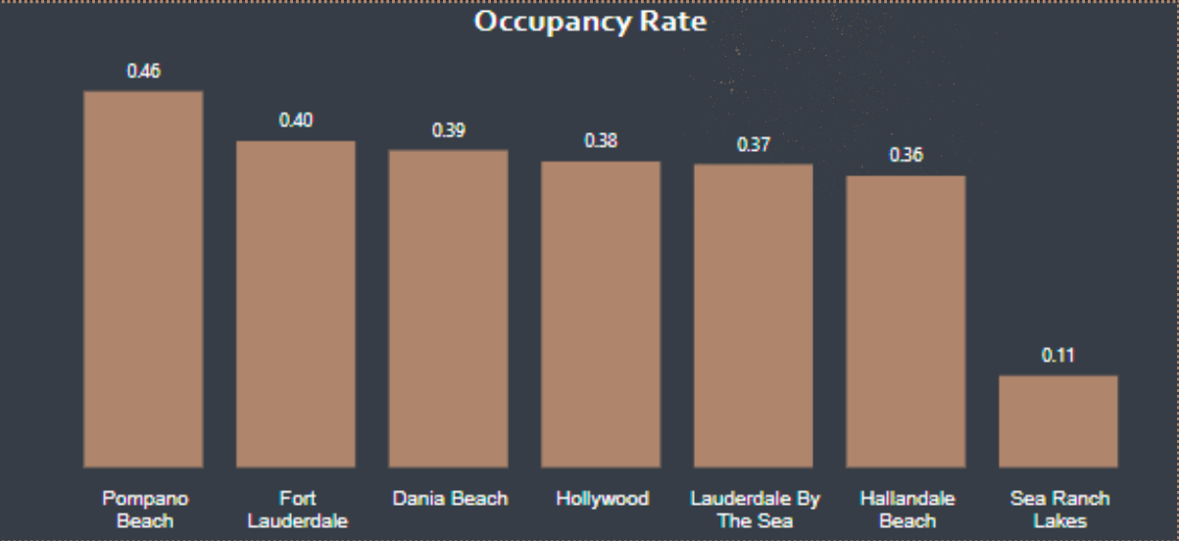

With that, Sea Ranch Lakes was excluded from the remaining pool of cities that are under consideration since it would be ideal to have a higher occupancy rate so as to fulfill another condition that the sisters have placed, which is to have the income generated by the investment property cover most of the cost of ownership. Lower occupancy rates here are assumed to lead to lower income. For good measure, a comparison of the average occupancy rate for the cities and their projected income was done as it is possible to have low occupancy rates and still have a comparable projected income with the other cities if the average nightly rate is high. In the combined bar and line chart below, it can be seen that Sea Ranch Lakes has a low occupancy rate and also a low projected income compared to the 6 other cities.

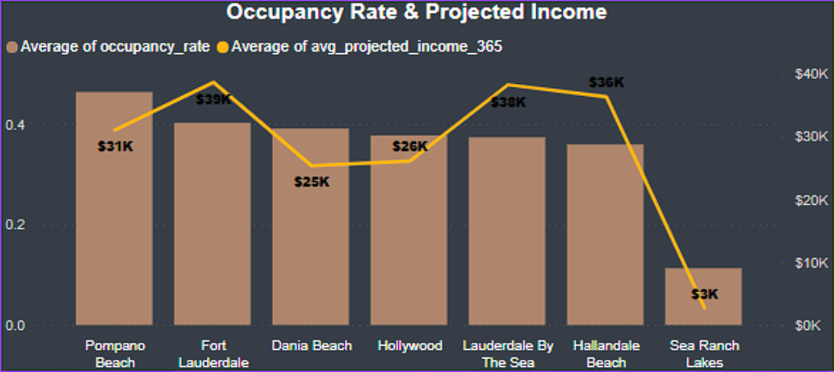

To further narrow down the consideration of cities, the estimated/projected income is considered. Prior to moving forward, however, a breakdown of the monthly costs for a possible investment property was determined. The following considerations were used for the computation:

**Home Price**: $ 400,000.00

**Down Payment**: $ 60,000.00

**Mortgage Interest Rate**: 6%

**Loan Type**: 30-Year Fixed

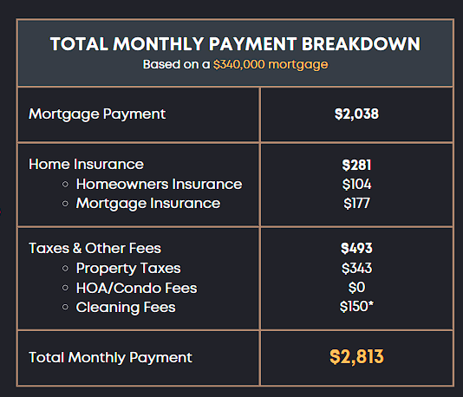

The sisters will need $ 33,756.00 per annum to make the computed monthly payments. This further narrows down the cities that would be ideal for the sisters to purchase property in as they would need at least this amount to be able to have the income from the property cover the cost of ownership.

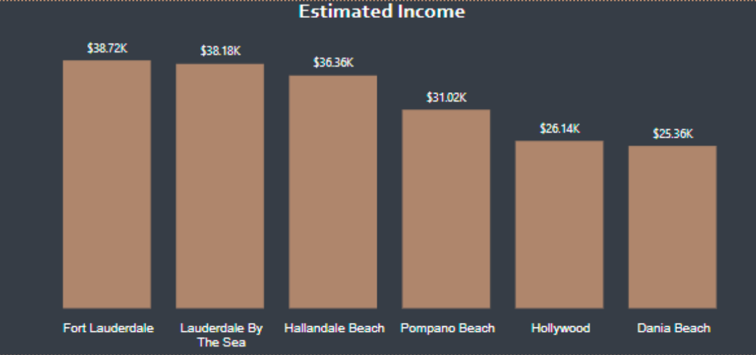

Looking at the chart for estimated income from the remaining 6 cities, it can be determined that only 3 cities (Fort Lauderdale, Lauderdale-by-the-Sea, and Hallandale Beach) are estimated and projected to be able to provide the needed amount of income to fulfill the sisters’ needs. Of note is that the values seen in the chart above reflect only that of listings that have 1-4 bedrooms. This was done with the sisters’ situation in mind. Each sister will want their own room, at the very least. Considering their budget and needs, bigger properties with 5 or more bedrooms would not be advisable or feasible.

# Conclusion

It has been found that 3 cities within Broward County would be suitable for the sisters to consider as locations for their investment property that they can rent out for 11 months out of the year. At the time of the research and analysis, it was found that Fort Lauderdale has the most number of properties on sale that are within the budget of the sisters from a cursory search of real estate listings.

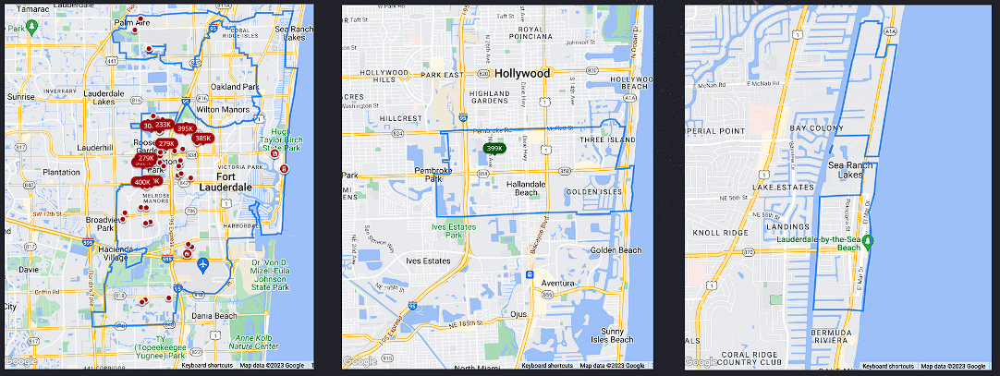

Fort Lauderdale is within 8 hours driving distance from Hazelhurst, Georgia. It is the central business district, hence there are restaurants and other establishments around. It is by the eastern coast and has beaches wherein the sisters will be able to swim and snorkel. These will be reachable by cycling or walking. It has listings for properties that are within the sisters’ budget. Through analysis of future bookings and pricing in the area, it is estimated that a property bought in Fort Lauderdale that is used for short term rental (given that it follows competitive or market standard pricing) will be able to generate enough income to cover the cost of ownership.

1. Limitations
2. **Lack of Data for Bookings Per Month**

The absence of monthly data limited our ability to analyze the seasonality and booking patterns over the course of the year. The monthly booking trends are essential for understanding the peak seasons, demand and other external factors like local events or holidays. Moreover, it would have been important to notify the sisters that in order for them to maximize their profits, they need to make sure the rental was available during the busy time period.

1. **Lack of Data for Revenue Per Month**

The detailed revenue data per month would have been a crucial insight into revenue trends, seasonal variations and the performance of the property during specific time periods. Through the help of the data, we could have identified peak earning months and optimized our pricing strategies accordingly.

# References

* *Get the Data*. (n.d.). http://insideairbnb.com/get-the-data/
* *Florida Mortgage Calculator*. (n.d.). SmartAsset. Retrieved November 15, 2023, from <https://smartasset.com/mortgage/florida-mortgage-calculator#nOLCgYBYmv>
* *Florida Mortgage Calculator.* (n.d.). SmartAsset. Retrieved November 15, 2023, from <https://smartasset.com/mortgage/florida-mortgage-calculator#nOLCgYBYmv>
* *Airbnb service fees - Airbnb Help Center*. (2023). Airbnb. <https://www.airbnb.com/help/article/1857>
* *Inc, Z*. (n.d.). Fort Lauderdale FL Real Estate - Fort Lauderdale FL Homes For Sale. Zillow.Retrieved November 15, 2023, from <https://www.zillow.com/fort-lauderdale-fl/>